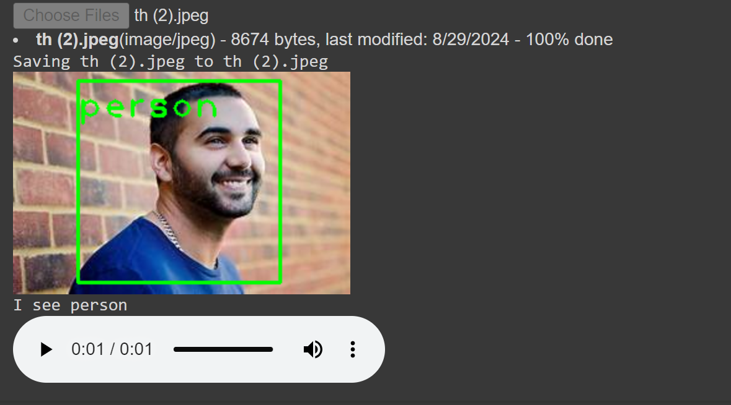

**Detection Summary:**

* **Object Detected**: Person
* The script has successfully identified the object as a "person" within the frame, and the corresponding text-to-speech output would be: **"I see person."** This output can be generated using gTTS or pyttsx3.